

Games Programming 2 Report

Module Name: Games Programming 2
Module Leader: Bryan Young
Module ID: M31626039
Student Name: Aiden Donkin
Matriculation Number: S2041059

I confirm that the code contained in this file (other than that provided or authorised) is all my own work and has not been submitted elsewhere in fulfilment of this or any other award.
Signature. Aiden Donkin

Contents Page
Section Page
- Project Outline…………………………………………………………………………………………………………3
- Loading, Rendering, and Movement of 3D Models…………………………………………………..3
- Collision Detection……………………………………………………………………………………………………4
- Application Audio……………………………………………………………………………………………………..4
- Extension Material……………………………………………………………………………………………………5
  - Camera Movement…………………………………………………………………………………………….5
  - Camera Angling………………………………………………………………………………………………….6
1. Project Outline
The aim of this project was to utilise C++ and openGL to create an application which met several key criteria. Firstly, the rendering and movement of three different 3D models, each with unique textures. This was achieved through the effective use of vectors, shaders and object meshes. Secondly, the presence of collision detection between the three models previously described. Thirdly, the presence of game audio which includes sound effects as well as background music. Each of these criteria will be discussed in depth in this report alongside several other features of the application.
2. Loading, Rendering and Movement of 3D Models
The 3D models present in the application were sourced from “TurboSquid.com” and were chosen due to their low file size. It was discovered early on through experimentation with different files and textures that files over 500kb slowed the application to a near halt and were not valid for a project of this scale. The models chosen were loaded into the application through the use of the function displayed in Figure 1.
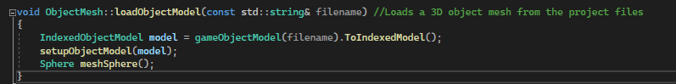
Figure 1: A code snippet displaying the “LoadObjectModel()” function taken from “ObjectMesh.cpp”
The “LoadObjectModel()” function was utilised in the MainGame.cpp file at an early stage of the application setup, in “SetUpSystems()”. This stage was carried out before any rendering of the application could be carried out.
The next major step was the initialisation of model textures and shaders. The steps to render a 3D model include setting the transform of the model, loading the relevant textures from the project files, binding the shaders, and drawing the object mesh. This process is displayed clearly in Figure 2. For the object specified in Figure 2, the “SinF()” function is used to determine the position of the object which is updated at the end of the “DrawGame()” by increasing the value of the “counter” variable by increments of 0.05. The gradual increase each loop provides the 3D model with the effect of movement across the screen.
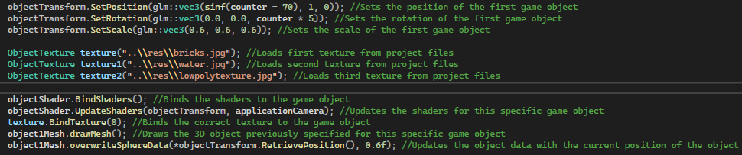
Figure 2: A code snippet from “DrawGame()” displaying the setup required to render a 3D object

The central code section of Figure 2 displays the process of loading the object textures from the project files. Similar to the 3D models, the textures chosen are of a low file size to prevent slowing of project compile time and increase the smoothness of the application while it is running.
A further iteration of the project was later created which altered a key part of Figure 2. Lines 5-7 which facilitated the loading of textures were removed from this function and were instead inserted into “SetupSystems()” which is only run once at the beginning of the application. This vastly differs from its previous placement in the “DrawGame()” method which is run every game loop. This led to a noticeable increase in efficiency when running the application.
3. Collision Detection
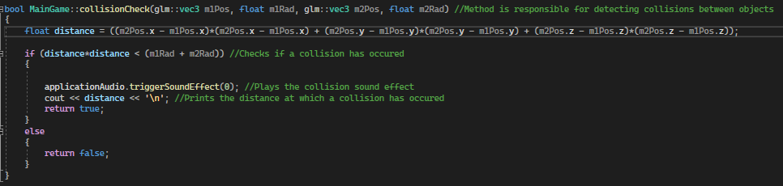
As stated earlier, collision detection was considered an essential feature in the creation of this application. As the 3D models move through the game space they occasionally collide and it was important to be able to record this and provide the user with data about the collision.
Figure 3: A code snippet displaying the “CollisionCheck()” function taken from “MainGame.cpp”
Figure 3 displays the function which is called during each game loop to detect whether or not a collision has occurred. The parameters required for this function include the position vectors of two game objects which have the potential to collide as well as the radius of each game object’s mesh sphere radius. As this application has been assembled without the use of a separate game engine such as Unity or Unreal, there are no collider components which can inform us of collisions independently. To bypass this issue, the detection of collisions simply depends on the measured distance between the two 3D models in the application world space. It can be clearly observed in the 3rd line of Figure 3 that in order for a collision to occur, the distance between the two game objects must be less than their combined radii. In the event of a collision, the distance between the objects at which the collision occurred is also printed to the user.
It is also visible in Figure 3 that a sound effect is triggered to notify the user of when a collision has occurred. This will be discussed further in section 4 of this report.
4. Application Audio
A further criteria for the project that had to be met was the implementation of audio tracks and sound effects for the application. Included in the final iteration of the project is a background music track and a sound effect which is played in the event of a collision.

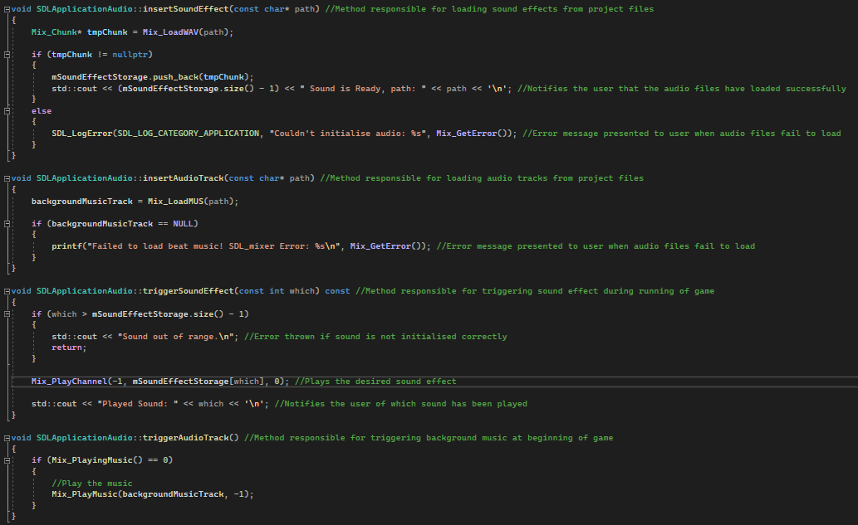
Figure 4: A code snippet from “SDLApplicationAudio” containing audio functionality.
Figure 4 displays the functions required to load and play sound effects and tracks from the project files. “InsertSoundEffect()” and “TriggerSoundEffect()” are used for the collision sound effect whereas “InsertAudioTrack()” and “TriggerAudioTrack()” are used for the background music. The audio files are loaded during the initial set up of “MainGame.cpp” in the “SetupSystems()” function. Much like the loading of textures discussed in section 2, the audio files are initialised prior to the running of the game loop to improve efficiency.
5 Extension Material
The sections previously discussed all pertain to what can be classed as core criteria for the project. Further features were attempted and added into later iterations of the project in an effort to improve the overall user experience.
5.1 Camera Movement
Providing the user with the ability to move the camera through the application world space was added in a near final version of the project. The user is able to move the camera in four separate directions on the x and y axes which allows for some light exploration through the application. To achieve this movement, functions were created to read the user input and determine which direction the camera should move in.

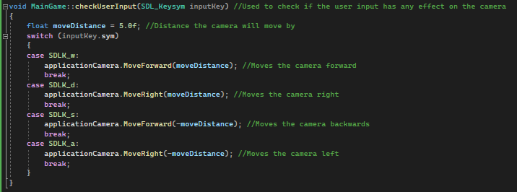
Figure 5: A code snippet displaying the “CheckUserInput()” function from “MainGame.cpp”.
The function displayed in Figure 5 defines the movement distance of the camera and also utilises a switch statement to determine whether or not the keyboard input from the user will result in a movement method being called. The keys chosen for this were ‘w’, ‘a’, ‘s’, and ‘d’ since they are the conventional movement keys for many applications. The “MoveForward()” and “MoveRight()” functions were defined in “Camera.h” and are displayed in Figure 6.
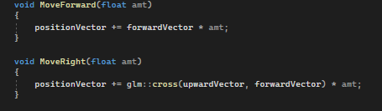
Figure 6: A code snippet from “Camera.h” displaying the camera movement functions.
5.2 Camera Angling
A second area which was focused on in the final stages of the project was the control of the camera view. The user being able to alter the angle and pitch of the camera allows for new perspectives to be explored and experienced. An SDL mouse motion event is used to track the user’s mouse movements before passing this data into the functions displayed in Figure 7.
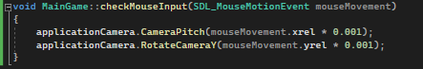
Figure 7: A code snippet displaying “CheckMouseInput()” from “MainGame.cpp”

The code displayed in Figure 7 shows a 0.001 multiplier being applied to the mouse movement data. This was implemented to combat the high sensitivity initially encountered when trialling the view movement. Without the multiplier, the camera moves far too fast for the user to be able to view anything in the scene. Figure 8 displays the definitions for the functions utilised in Figure 7.
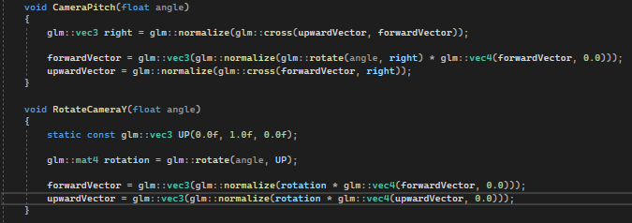
Figure 8: Code snippet displaying the definitions for the camera view control functions.
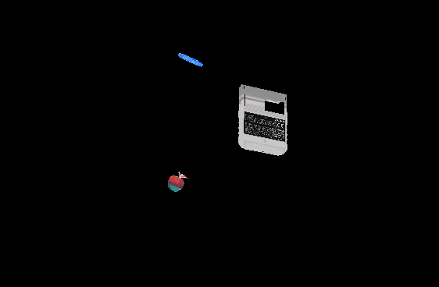
Figure 9: Screenshot of the application in progress.

